K-brace
PP Strut Tower Brace kit + Cowl Extension + Lower K Brace Install Guide

I decided to make a thread instead of just adding it as a post to the existing...2 or more threads, so it might be easier to for people to find.
I just did the install today so everything is fresh in my mind.
The purpose of this post is to tell you the appropriate part numbers, quantity, and how to install the Ford Racing strut tower brace kit, the OEM cowl extension panel, and the lower K brace. These parts are standard on Mustang GT Performance Pack cars, but for the rest of us peons, we have to add them after the fact.
WHAT YOU WILL NEED:
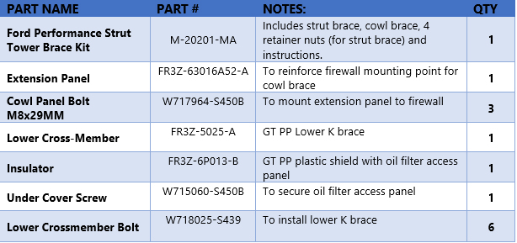
And, to remove the windshield wipers, a windshield wiper arm puller tool, $13 at advanced auto or any flavor of the month auto store. You may not need it, but I did.
PART 1: INSTALLING THE STRUT TOWER BRACE KIT AND EXTENSION PANEL
The first thing to do here is follow the directions that came with the kit, or, use American Muscle's instructions, which I found to be better. If you are following AM's instructions, do everything they say up until step 6.
Now you should have the plastic brace off and your cowl should be loose, but still held in place by windshield wipers....
1. Remove the wiper arms. They are secured by a 15mm bolt under a rubber cap, if it doesn't just pop off, use the puller tool.
2. Look at your extension panel to see how it fits. This photo shows the orientation it will install at, with the bottom of the image facing towards the front of the car.
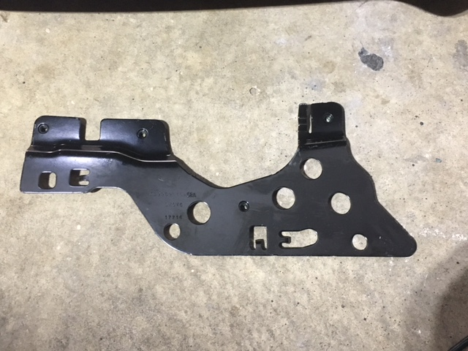
3. While holding the cowl up (they are sealed to the windshield so it won't come off completely) with a piece of something, angle the cowl extension piece into place and secure it. There are 3 holes in the firewall behind the wiper motor arms that indicate where the threaded holes of the cowl extension panel should align. They go underneath the lip of the firewall and there's a tab that holds it in place. It makes more sense when you are actually doing it, trust me.
This shows how it should fit:
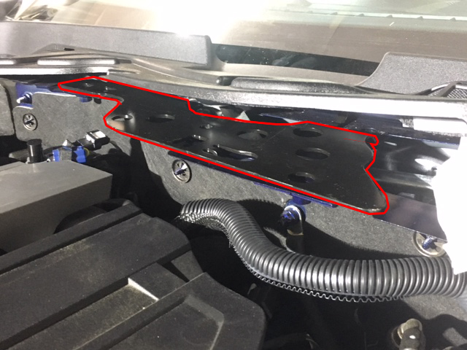
4. Now, take your 3 cowl panel bolts, which are identical to the 4 bolts you already removed to take out the plastic cowl brace, and install them into the BACK SIDE of the cowl extension panel. DO NOT install anything on the front side yet. Torque to 26 ft/lbs
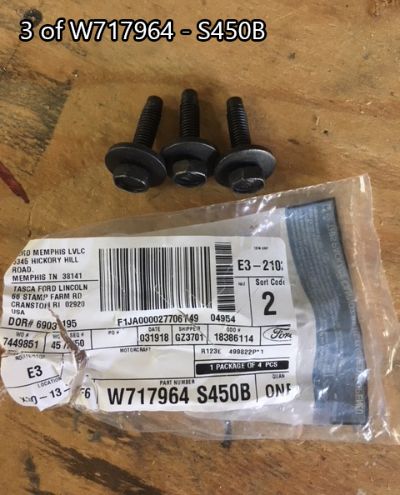
You can see in this image where the bolts should go (circled)
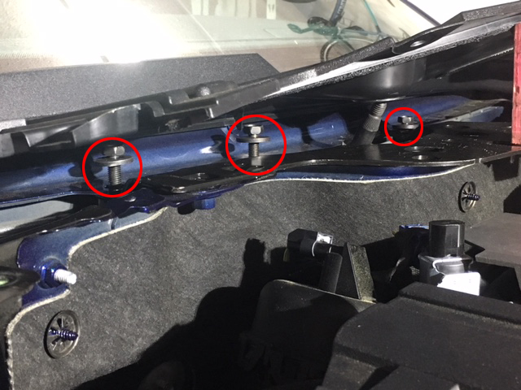
And another angle with them secured, and my 2x4" piece that I used to hold the cowl up.
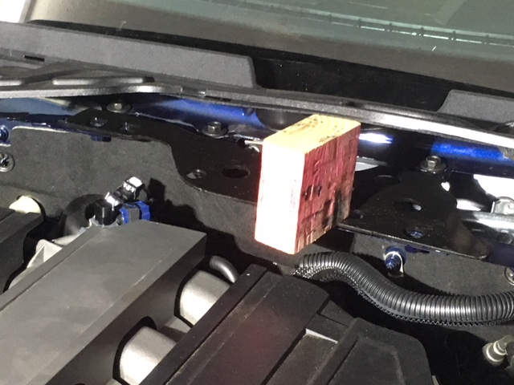
Now, continue where you left off on American Muscle's STB install instructions (step 6), and reinstall your windshield wipers.
Part 1 is done!
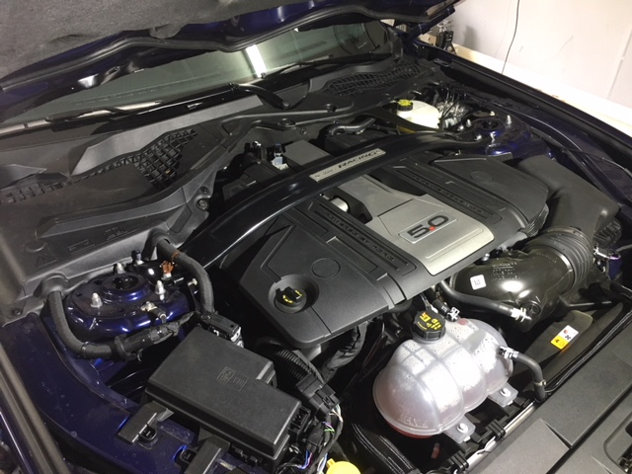
PART 2: GT PP LOWER K BRACE AND INSULATOR PANEL
1. Jack up the front of your car and chock the rear wheels (etc etc).
This is what you will see:
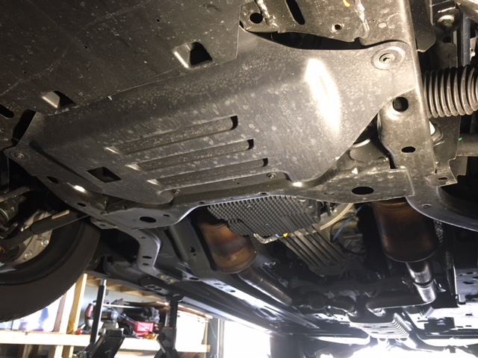
That ribbed plastic piece is the 'insulator' that the non-PP cars have. There are 6 small bolts holding it on, remove them all and pop the insulator out.
This is the GT PP lower K brace, it is oriented in the way it will install (bottom of image towards the front of the car)
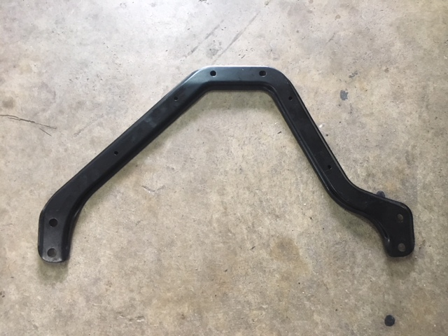
2. Take 4 of the small bolts your just removed from the other insulator, and secure your new insulator onto the K brace, note how the pieces fit together in the image below. In this pic, it's flipped upside down to show the bolts. The flap that you see is actually going to be on the right (driver's) side when you install it.
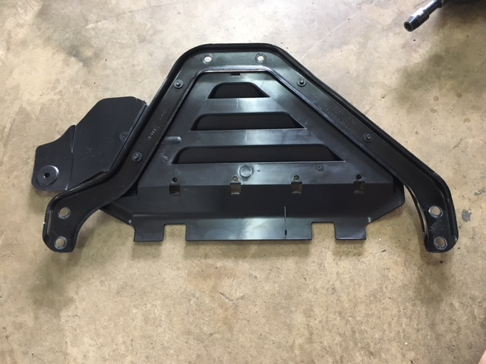
3. Take your cocktail of parts and hoist them into position, there will be 6 obvious threaded holes that you probably noticed upon removing your original insulator. If you were thinking these are the holes that you need to install the 6 lower cross member bolts (pictured below), then you'd be right.
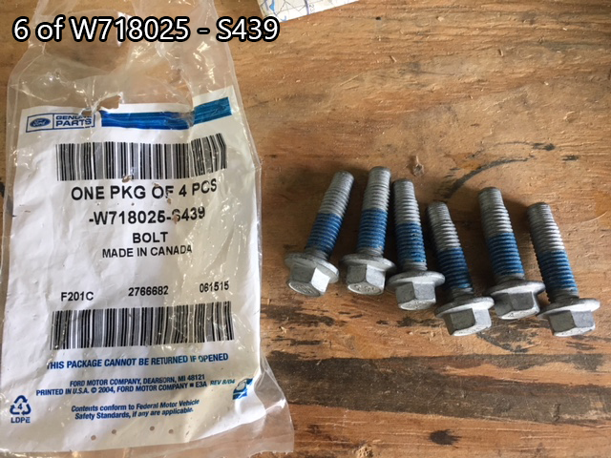
Install the 6 bolts and torque to 41 ft/lb.
Reinstall 2 of your 3 remaining insulator bolts (small ones) to the front holes that secure the insulator to the large plastic splash shield (Square indentations).
Now take your 1 extra small bolt that you had to order (you can see that I ordered 2 too many):
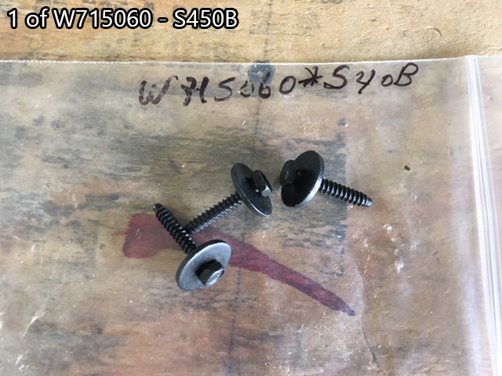
Install it to hold up the oil filter access panel (it's obvious)
Finished product:
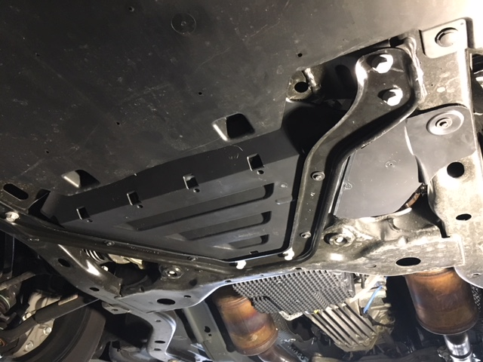
Remove jack stands, lower the car, etc etc. Drive.
B

